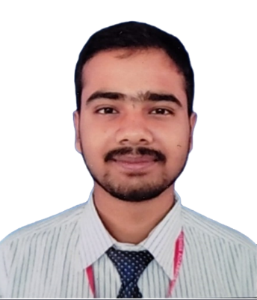

Personal Details

**Name:** Kaushal Kumar Ray

**Father’s name:** Dipendra Ray

**Nationality:** Nepalese

**Date of Birth:** 27/04/2004

Passport Details

**Passport no:** PA1783264

**Date of issue:** 14/06/2023

**Date of expiry:** 13/06/2033

Contact

**Address:**

Barahakshetra-6, Sunsari- Nepal

**Phone:**

+9779829396375

**Email:**

[raykaushal888@gmail.com](mailto:raykaushal888@gmail.com)

Languages

* Nepali
* English

Hobbies

* Writing
* Listening music
* Photography
* Graphic designing

Kaushal Kumar Ray

­Education

* + Basic Level Examination (**BLE**): From Sunsari Garden Academy with GPA= 3.07 in 2018.
  + Secondary Educational Examination (**SEE**): From Sunsari Garden Academy with GPA= 3.55 in 2020.
  + School Leaving Certificate (**SLC**): From Vishwa Adarsha Secondary School (NEB) with GPA = 2.67 in 2023.

Certifications

* Computer course of **Basic** and **Diploma**. (May 2021)
* Certificate of achievement on submitting a presentation on the **Internet of Things (IOT)** as a team leader. (Dec 2022)
* The Fundamentals of Digital Marketing from **Google**. (May 2023).
* Build a **Generative AI-based** Automated Image Captioning and Visual QnA Engine. (July 2023)
* **COVID-19:** Effective Nursing in Times of Crisis. (August 2023)
* International English Language Testing System **(IELTS)**:- Listening: 7.0, Reading: 6.5, Writing: 5.5, Speaking: 5.5 Overall: 6. (Sep 2023)
* Scholastic Assessment Test **(SAT)**:- Reading and Writing 480, Math 610. Total score: 1090. (Nov 2023)

Skill Highlights

|  |  |
| --- | --- |
| * Project management * Strong decision maker * Complex problem solver | * Creative design * Innovative * Service-focused |

Experience

* Familiar with Adobe Photoshop (7.0) and MS Office from 2020 to the date.
* Have Basic knowledge of computer hardware and capable of fixing minor problems.
* Worked as a volunteer to teach basic computer software.
* Familiar with C-Programming and Web Development while in high school from 2021 to the date.